

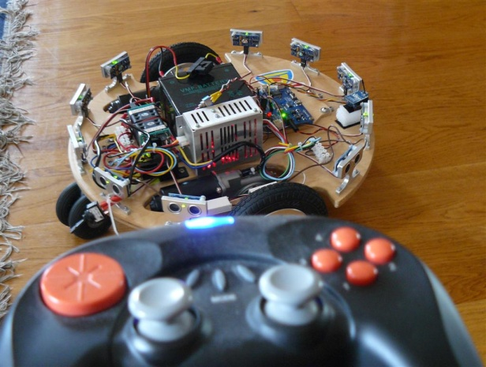
User manual Skimmer Propeller SW
Sw version 13
06-July-2011
H.J. Kiela

Introduction:
The Skimmer is a robot development platform to develop and test autonomous robot applications. This platform is a relative cost effective solution and allows easy connection to for example the Robot Operating System (ROS) of Willow Garage.
The platform holds its own controller to drive the wheels with speed and position, communicate with for example the ROS-host PC or laptop and implement basis safety on platform level.

Instruction set:
The platform can be controlled in two ways:
- Joystick Xbee module
- PC Xbee communication

Xbee remote control:
Uses string handling for xbee command line handling

Example command string
XB$500,33251,-369,-88,0,0,0,0,# Id ($500),Cntr,JoyX,JoyY,Btn1,btn2,btn3,btn4 No response

PC control:
Move command : $900,cntr,speed,dir : where speed and dir = [-128..128]. No resoponse
Enable motion : $901,Enable Enable : 0=no motion 1= motion allowed No response
Enable PC control: $902,PcEnable PcEnable=0 or 1 No response

Enable/DisablePf US sensors : $909,Enable Where Enable = [0,1] When DisablePfd, no distance check active! No response
Clear Errors : $908 (No parameters), No response

Query wheel pos : $911 Returns 2 wheel positions as word. Reponse: $911,Int16 [Wheel1], Int16[wheel2], <cr># (Sign has no meaning)
Query US sensors : $912 Return 10 US sensor readings in mm. Sensor 0 is right front, counting ccw. Response: $912, Int [Sensor[0], ….., Sensor[9],<cr>#
Query Status : $913 Query status of various par's, like errors, platform status, life counters Xbee comm time.
Response: $913,
[MoveMode], 'Mode mode 0 = manual 1= US sensor control
[LastAlarm], 'Last error
[XbeeTime/80000], 'Time of Xbee comm in ms
[ppc.getCntr], 'HB52 counter to check life
[Enabled], 'Platform Enabled 0= disabled 1 = enabled or Enable = -1 Disabled = 0 ??
[PcEnable], 'Pc has control Enabled Enable = -1 Disabled = 0
[PfStatus], 'Platform status 'Platform status bits
Serialbit = 0 '0= Serial Debug of 1= Serial pdebug port on
USAlarm = 1 'US alarm bit: 1= object detected in range
PingBit = 2 '0= Ping off 1= Ping on
EnableBit = 3 '0= Motion DisablePfd 1= Motion enabled
PCEnableBit = 4 'PC Enable -> Pf Enable
PCControlBit = 5 'PC In control
CommCntrBit = 6 'Xbee Timout error
MotionBit = 7 'Platform moving
NoAlarmBit = 8 'No alarm present
[MainCntr], 'Main loop counter
[SafetyCntr], 'Safety loop counter
[Version] 'Software version
<CR>#<EOT>

Components:
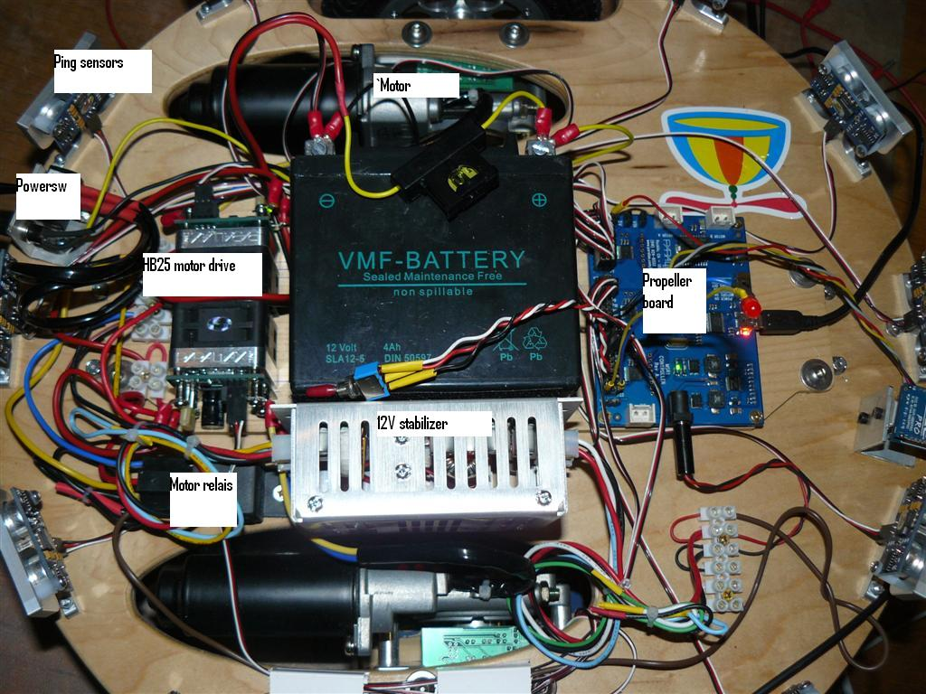

Requirements
You need a Pc with windows, a joystick the Skimmer and a Xbee board with USB connector.
1 Install the propeller IDE and copy the Skimmer software to a location on the hard drive.
2 Install the Parallax terminal. After installation, connect the USB connection of the Propeller board to the PC
3 Install the Xbee Xtu software and drivers. Make sure that when connecting the Xbee that the XTU driver installs properly and a new serial USB-port is created.
4 Install the Xbee Platform controller software
5 Run the Parallax Terminal and switch the robot on. After a few seconds the Propeller powers up and the HB25 drives will start their fan’s.
6 Make sure that the Debug switch is put in the Debug position. Now a screen like below should appear on the Parallax terminal.

If not, check the debug switch
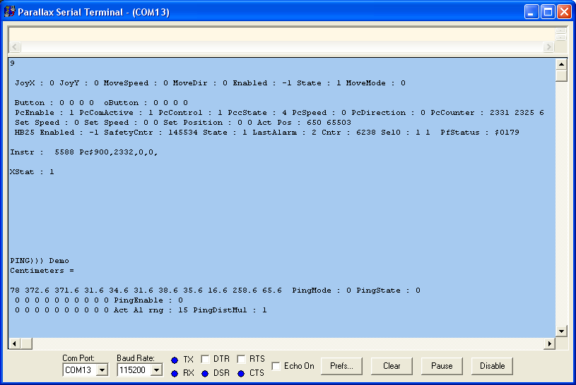
7 Switch on the Joy stick remote control and check that the degug screen show an Incoming string starting with XB500, etc.
If that all is OK, continue, if not, go to debug Xbee.
8 Start the XTU utility. Open the Xbee on the right com port, select a baud rate of 115000 baud and move to the ternibal window. You should see the remote control strings, passing. These start with XB$500, etc.

9 Close the XTU-utility and start the Xbee platform controller. Check and correct if needed the communication settings first, to the same settings as used in the XTU utility.
10 Enable the communication, Joystick and Status Timer. You should see a lot of incoming and outgoing info. But the lover part of the screen should show understandable status info.

The first moves
Use the remote control to move the platform.
Steps from the Joy stick.:
- Press button 4 (right) to clear errors
- Press button 2 to disable the US sensors
- Press button 1 to enable motion. Carefully move the joy stick side ways and forward and backward.
- Press button 1 to disable the platform again.
Steps from the PC
- Enable PC comm
- Press reset
- Enable the joystick
- Enable PCEnable, to allow motion. Now move the left joystick carefully in any direction
- The functions are also available on the joystick buttons: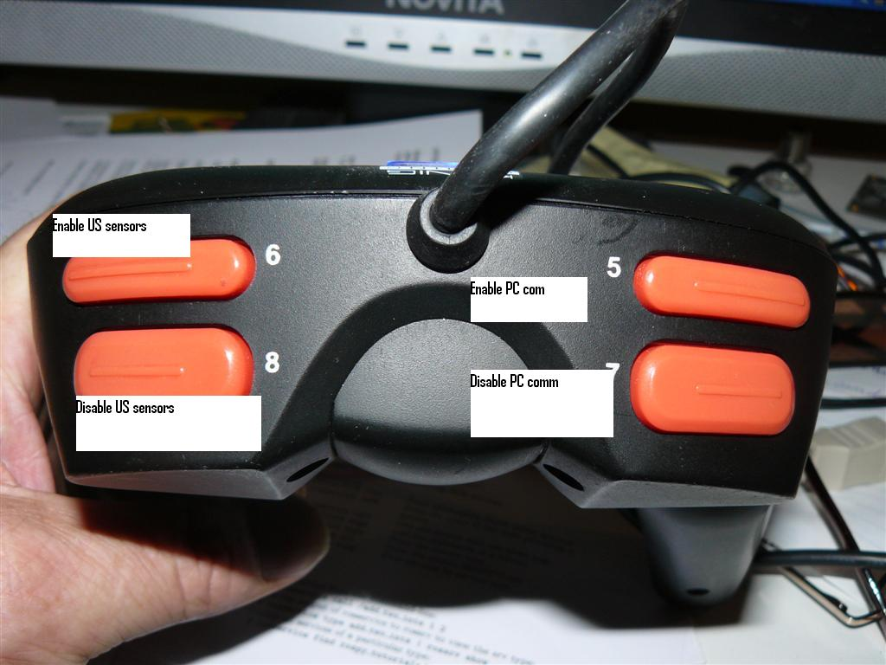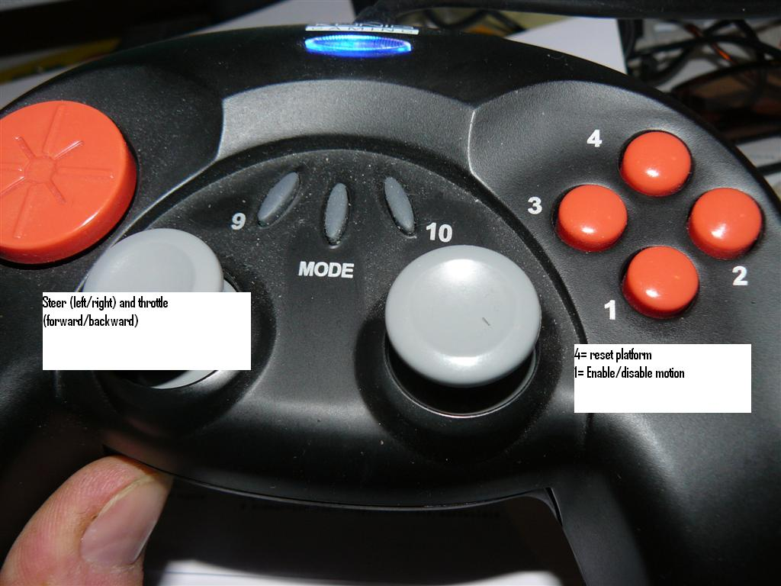

The Ping sensors
The platform has 10 ultra sonic distance sensors. With all the physical charateristics of these sensors, thay can be use as a safety device.

The sensors can be switched on and off. When on, the green leds’blink. When moving forward, the forward pointing sensors are active (while all keep blinking) If an object is found within the safety disatnce in the moving direction, the platform shuts down and an error is shown. The sensors that found an object are blinking slowly.
The same behaviour can be expected when driving backward.
This condition can be reset by the reset command.
If the sensors are switched off, No checking is active!

Some notes:
- The safety distance is speed dependent. At slow speed the range is around 100 mm, at max speed the range is 500 mm, to allow for more braking distance.
- The safety distance is a semi circle around the platform in the direction the plat form is moving!
- Hard materials and corners reflect more that soft thin ovjects! This can make a huge difference in detection distance for the samen set distance.

